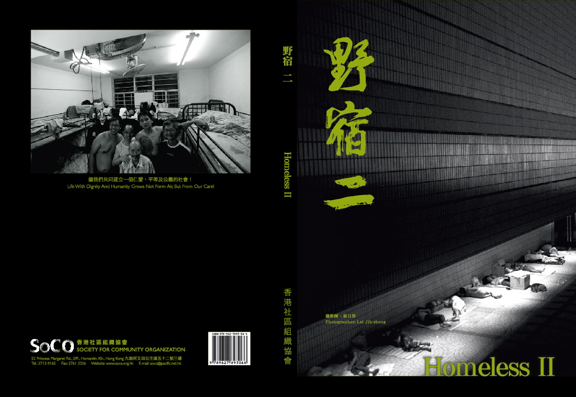

《野宿二》露宿者攝影集
如果可以數得出100種自殺的方法，相信100種生存下去的方法，更值得去看。

2002年，本會出版了首本紀錄香港露宿者情況的《野宿》，書中紀錄了99-02年金融風暴下，一夜間變得無人無物的露宿者，那時是香港露宿者的全盛時期，露宿者來自各階層，每晚入夜，他們從四方八面湧至，那年頭最搶手是用來墊著睡覺的紙皮箱。

事隔八年，從數字來看露宿者情況有所改善，但露宿者反而愈來愈年輕，二十來歲的露宿者成為小社群在網吧渡日；當中學歷愈來愈高，甚至有讀過大學，做過高官的露宿者，他們均活在一個無奈的循環中：失業──露宿──找到散工──失業──再露宿。

我們再次結集在人生邊緣間掙扎求存的露宿者故事。對，還請記著，故事仍未劃上句號，只要他們一天仍努力地活著。

If a person can come up with a hundred ways to end his life, we think it is more worthwhile for him to come up with a hundred ways to continue living.

In 2002, SoCo published the first book Homeless, which recorded the situation of street-sleepers. The book contained records of those street-sleepers who lost their friends, relatives and property overnight in the financial turmoil from 1999 to 2002. That was the peak period of the street-sleepers, who came from various social strata. At night, they came from different directions. What in most demand was paper cartons to be spread on the floor for sleeping.

After a lapse of eight years, it appears from statistics that the situation of street-sleepers has improved. On the other hand, however, there is a gradual drop in the age of street-sleepers. The 20-odd year old street-sleepers have become a community spending their days in internet bars. The education level among them becomes higher and higher. Some even had studied in universities or were previously senior government officials. They have been living in a helpless cycle: unemployed, find casual jobs, unemployed, sleep in the streets again.

We have collected again the stories about street-sleepers in Hong Kong, who have been struggling hard to keep their heads above the water. As long as they continue to strive hard for a living, their stories will never end.

---------------------------------------------------------------------------------------------------------------------------

《野宿二》露宿者攝影集訂購表格
Homeless II Photo Album Subscription Form

＿＿＿本Copy(ies) x $150 = $＿＿＿＿＿

姓名Name：＿＿＿＿＿＿＿＿＿＿
地址Address： _________________________________________________________________________________
電話Tel.：＿＿＿＿＿＿＿＿＿＿ 電郵E-mail：＿＿＿＿＿＿＿＿＿＿

訂購方法：
請將回條連同劃線支票（抬頭「香港社區組織協會有限公司」）寄回本會；或請將款項直接存入本會匯豐銀行賬戶（017-6-041937），並將存款收據及回條一併寄回本會。本會將寄奉正式收據，訂購滿港幣一百元，可憑收據申請扣減稅項。
To subscribe:
Please use crossed cheque payable to “Society for Community Organization Ltd.” and enclose with this form and send them to SoCO; or transfer the amount to SoCO’s saving account at Hong Kong Bank (A/C: 017-6-041937). Subscription over HKD 100 will be tax deductible and the official receipt would be provided.

本會地址：九龍何文田公主道52號3樓
SoCO Address: 3/F, 52, Princess Margaret Road, Homantin, KLN
電話 Tel. ：27139165 傳真 Fax ：27613326
電郵 E-mail ：soco@pacific.net.hk 網頁 Website ：www.soco.org.hk

